Objectives
- Explain the need for Unit Testing in React
- Working with Jest and Enzyme in React
- List the types of Router Components

In this hands-on lab, you will learn how to:
- Install and configure Enzyme
- Create unit test using describe(), test()
- Mount component and test them using matchers
- Capture snapshots of the React components

Prerequisites

The following is required to complete this hands-on lab:
- Node.js
- NPM
- Visual Studio Code

Notes

Estimated time to complete this lab: 90 minutes.

My Academy team at Cognizant want to create a dashboard containing the details of ongoing and completed cohorts. A react application is created which displays the detail of the cohorts using React component. You are assigned the task of unit testing the component to ensure it’s free of bugs.
Download the following attachment to find the application code.
- Unzip the attachment and open it in visual studio code.
- Open the terminal and execute the following command to restore the node modules
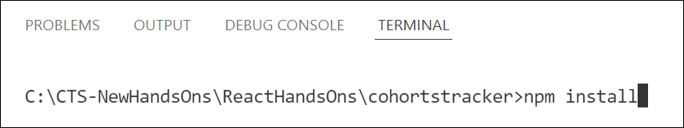
Figure 1: Packages Restore
- Execute the following commands to install Enzyme and Enzyme test adapter

Figure 2: Installing Enzyme support
- Go to file explorer and modify the setupTests.js file to make it look like the following

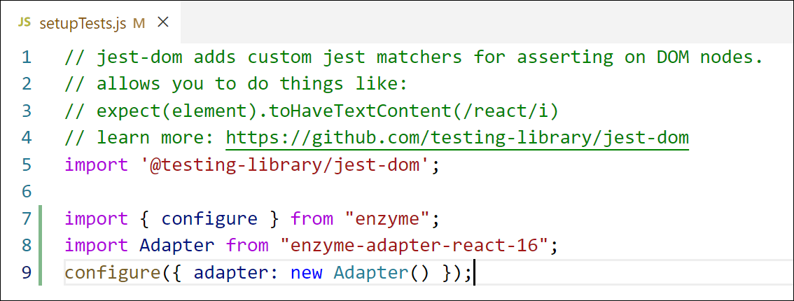
Figure 3: Configuring Enzyme support
- Add a new unit test file with the name as CohortDetails.test.js to write the unit tests for the CohortDetails component defined inside CohortDetails.js file.
- Import the following into the unit test
  - mount, shallow from Enzyme library
  - CohortDetails component
  - CohortData array from Cohort.js file
- Define a test suite using describe() and name it as “Cohort Details Component”
- Define the following unit tests using test()
Table 1: Unit Test - 1
Test - 1 | Name: should create the component
A unit test which will load the CohortDetails component in isolation

Table 2: Unit Test - 2
Test - 2 | Name: should initialize the props
This test should mount the component and assign a cohort object to the props. Using matchers ensure that the props are assigned a given cohort object

Table 3: Unit Test - 3
Test - 3 | Name: should display cohort code in h3
This test should mount the component and search for an h3 element using find() and verify that it displays the proper cohort code of the object passed in props

Table 4: Unit Test - 4
Test - 4 | Name: should always render same html
This test should be responsible for testing the snapshot of the component.

- Build and run the tests using npm test command.

